Lauren Berryman

Prof. Minkoff

Data Journalism

26 February 2022

**Google Trends**:

**A woman’s right to an abortion is up in the air**

Abortion access in America is up for debate nearly 50 years after the U.S. Supreme Court’s landmark decision in *Roe v. Wade*. Whether to limit access will once again be up to the court, which now leans conservative.

According to Google Trends, searches for “abortion clinic” are on the rise. In May 2019 and December 2021, searches for “abortion clinic” reached their peaks.

In May 2019, Alabama lawmakers passed a law making it illegal for doctors to perform abortions at practically any stage of pregnancy, CBS News [reported](https://www.cbsnews.com/news/abortion-ban-protest-today-new-laws-spark-marches-nationwide-2019-05-21/) that month. In December 2021, the U.S. Supreme Court heard [oral arguments](https://www.youtube.com/watch?v=MRe4mYcEqBM) regarding the constitutionality of a Mississippi abortion ban.

Both instances sparked outrage among the pro-choice community. Women’s rights advocates organized protests across the country. These instances also made those considering abortions worried their opportunity may run out soon.

While searches for “how to have a miscarriage” have remained relatively low between 2004 and 2022, the data shows people continue searching for it. This search is alarming because attempting to have a miscarriage can have harmful and possibly deadly consequences.

Searches like “how to have a miscarriage” are why many people advocate for women’s rights. The extent of a woman’s right to make her own reproductive decisions has fluctuated, and the Google Trends for these two searches show just part of the matter.

One in four women will have an abortion by age 45 in the United States, according to a 2017 [report](https://www.guttmacher.org/article/2017/10/population-group-abortion-rates-and-lifetime-incidence-abortion-united-states-2008) by Guttmacher Institute, a reproductive research organization. According to Google Trends, people were searching for these terms in the context of “abortion clinic near me,” “abortion near me” and “abortion pill near me.”

But for those who may have been barred from going to an abortion clinic, some searched “how can you have a miscarriage,” “how long does it take to have a miscarriage” and “early miscarriage.”

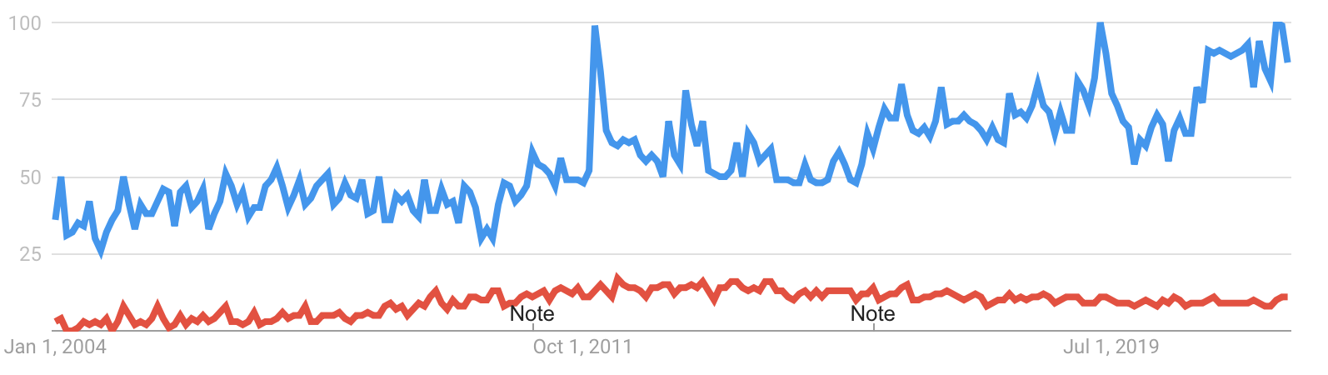

** blue: “abortion clinic”

** red: “how to have a miscarriage”

______________________________________________________________________________

**The rise and fall of searches for “vegetarian” and “vegan”**

***(not newsworthy)***

The word “vegan” is searched for significantly more than the word “vegetarian” in the United States today. But this has not always been the case.

When Google first started following search trends in 2004, “vegetarian” was searched more than “vegan.” However, both words were searched for almost the same amount.

The word “vegetarian” has been searched consistently between 2004 and 2022. But ever since June 2010, “vegan” has been searched more. And ever since February 2011, “vegan” has been searched more frequently than “vegetarian” worldwide.

Starting in September 2016, searches for “vegan” took off. In August 2017 and November 2019, searches for “vegan” reached peak popularity, according to Google Trends.

Santa Monica, California, Portland, Oregon and Oakland, California were the top cities where people searched for “vegan” over these 18 years. Oakland, California, Portland, Oregon and Sunnyvale, California were the top cities where people searched for “vegetarian.”

When searching for “vegetarian,” people used them in the context of “vegetarian near me,” “vegetarian restaurants near me” and “vegetarian food near me.” When searching for “vegan,” they typed “vegan near me,” “vegan food near me” and “vegan restaurants near me.”

Today, searches for “vegan” are 25% less popular than their peak. And searches for “vegetarian” remain roughly the same as always.

Google users in Washington, D.C. search “vegetarian” more than the states. But still, people in Washington, D.C., on average, search “vegan” more. The data also show that people in Nevada have more interest in searching “vegan” than Washington, D.C. or any other state.

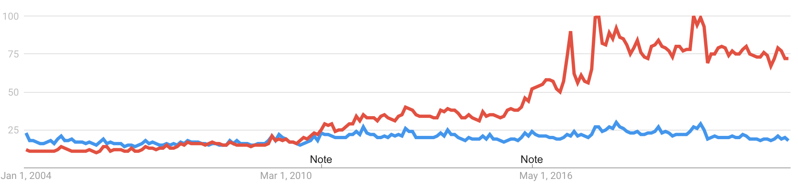

** blue: “vegetarian”

** red: “vegan”

______________________________________________________________________________

**Google Book Ngrams**:

**Americans prefer quick fixes to disease prevention, indicated by Google Book Ngrams**

Today, health experts say Americans prefer a “quick fix” mentality to preventing cancer, which is reflected in this Google Book Ngram.

While mentions of “cancer treatment” and “cancer prevention” started taking off at relatively the same time, “cancer treatment” continued at a steep upward trend, while mentions of “cancer prevention” began declining in the early 2000s, according to the books Google Books has collected.

This trend is also reflected in cancer diagnosis and mortality rates. For example, from 1975-2018, the mortality rate of pediatric cancer declined, but the incidence of pediatric cancer increased, according to Centers for Disease Control and Prevention [data](https://wonder.cdc.gov/cancer.html).

Still, as the National Cancer Institute director, Norman Sharpless, explained in a blog [post](https://www.cancer.gov/news-events/cancer-currents-blog/2021/childhood-cancer-accelerating-progress-sharpless) this past September, acute lymphoblastic leukemia was almost always a death sentence in the 1950s. But today, more than 90% of children with this cancer are cured due to advancements in treatments.

Although not reflected in the Ngram, comparing mentions of “cancer treatment” and “cancer prevention,” President Joe Biden’s [relaunch](https://www.whitehouse.gov/briefing-room/statements-releases/2022/02/02/fact-sheet-president-biden-reignites-cancer-moonshot-to-end-cancer-as-we-know-it/) of the Cancer Moonshot Initiative on Feb. 2 continues the focus on cancer treatment over cancer cure. The initiative calls for all-hands-on-deck to reduce the cancer death rate by 50% within the next 25 years.

With cancer incidence on the rise, many health experts worry about the repercussions of the roughly 10 million cancer screenings Americans missed during the Covid pandemic, which was reported in a [study](https://pubmed.ncbi.nlm.nih.gov/34866184/) in December.

Outside of prevention, early detection is key to the best cancer outcomes. Without making a diagnosis, proper treatment cannot begin.

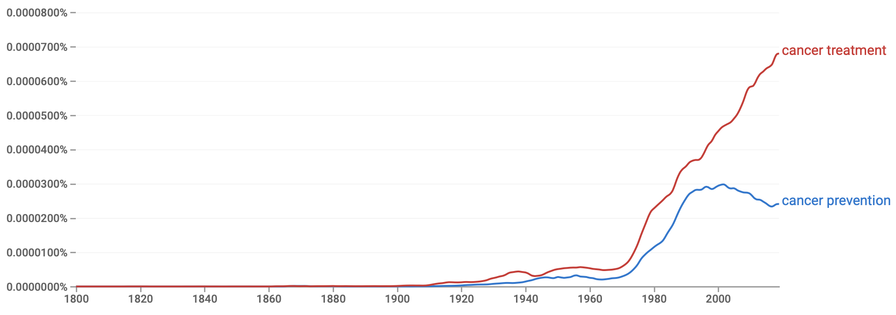

______________________________________________________________________________

**Mention of “creation story” and “big bang theory” over time**

***(not newsworthy)***

In the books Google Books has collected, mention of “creation story” and “big bang theory” has fluctuated over time.

From 1800 to 2019, “creation story” has always been mentioned more than “big bang theory.” Mentions of “big bang theory” in these books first started in 1866, whereas mentions of “creation story” began in 1806.

These terms started getting mentioned more frequently at different points in time. “Creation story” started taking off around 1885, while “big bang theory'' started taking off around 1960. This instance could be related to the U.S. Supreme Court case *Epperson v. Arkansas*. This case overruled an Arkansas law barring the teaching of evolution in public schools.

After this moment, mention of “big bang theory” as well as “creation story” soared in the books available on Google Books.

In the late 1800s, “creation story” was mostly mentioned in republications of the Genesis story or in books analyzing the story. During this time, it is hard to find “big bang theory” mentioned in books because it was so rarely included.

More recently, “creation story” is mentioned in the context of the “Mayan creation story” and the “Native American creation story” as well as in books actually about evolution.

“Big bang theory” is largely mentioned in the context of the television show, autobiographies about the actors in the show and reboots of the show.

Between 2017 and 2019, mention of both terms has slightly declined, so it would be interesting to learn more about the data from 2019 to 2022 to see if their mentions in books are still going down or are back up.

